Your local NHS is open for business

Communications toolkit

- Web copy
If you are feeling unwell and need medical help, you should still continue to contact your GP practice as normal in Birmingham and Solihull – although how you access local services is likely to be different during the COVID-19 pandemic.
While the NHS has been busy dealing with COVID-19, it is still here and ready to help if you or a family member is feeling unwell; which is why patients are being encouraged to continue to seek help if they need it and attend any medical appointments that are booked.
Please visit the NHS Birmingham and Solihull website for more information.
- Expanded web copy

Help us to help you get the treatment you need across Birmingham and Solihull

If you are feeling unwell and need medical help, you should still continue to contact your GP practice as normal in Birmingham and Solihull – although how you access local services is likely to be different during the COVID-19 pandemic.
While the NHS has been busy dealing with COVID-19, it is still here and ready to help if you or a family member is feeling unwell; which is why patients are being encouraged to continue to seek help if they need it and attend any medical appointments that are booked.
Dr Richard Mendelsohn, a Birmingham GP and the Chief Medical Officer of NHS Birmingham and Solihull Clinical Commissioning Group, said: “We want all our patients to feel confident that the NHS is still open for business and able to look after both people with COVID-19 and other health issues. A lot of work has been done locally to keep our patients safe, with doctors offering telephone or video appointment, as well as specific sites set up for routine and urgent care needs in primary care.
“People should not be put off getting medical help if they are feeling unwell or are worried about symptoms they have developed, and to contact their GP practice or NHS 111 as normal. Repeat prescriptions should also continue to be ordered – which can be done digitally and picked up from a local nominated pharmacy – women should continue to attend antenatal appointments and seek advice from their midwife, and babies and children should be taken for routine vaccinations in order to protect them against serious and potentially deadly illnesses.”
Birmingham and Solihull healthcare options:
• COVID-19 Care Assistant: This free 24/7 online service, accessed through Ask A&E and powered by Babylon, offers information on COVID-19 and self-isolating, with a free online symptom checker and access to live chat (8am-8pm) with University Hospital of Birmingham NHS Foundation Trust clinicians.

• GP practice: Telephone your GP practice as normal. You may be offered a telephone or video appointment. If you require a face-to-face appointment you will be told by your practice where to go. Different sites are operating across Birmingham and Solihull in order to keep patients safe, with separate sites for those needing routine care such as vaccinations, maternity, baby checks, dressings and urgent blood test, and alternative locations for those with acute medical problems, people who are shielding or under 16s who are not suitable for a virtual consultation.

• Pharmacy: Local pharmacies are open as normal. Please do not attend if you have COVID-19 symptoms.

• NHS 111: This is available 24/7 by calling 111 or visiting https://111.nhs.uk/

• Walk-in, urgent care or urgent treatment centres: Locally, some of these options are still available – please check on the NHS website to ensure that your local site is open. Please do not attend if you have COVID-19 symptoms.

• A&E: You can use the Ask A&E symptom checker to find out if you need to attend your local A&E if you are not sure. Please only attend A&E or call 999 if it is a life-threatening situation – for example a heart attack or a stroke.

Dr Mendelsohn added: It is important, during this time of social distancing that if people are feeling unwell – either physically or mentally – that they know they can access healthcare. You can find out more about local services on our website here. In Birmingham and Solihull we also have a local mental health offer targeted at 0-18s in Birmingham, 0-19s in Solihull, over 18s in Birmingham and Solihull and key workers, and you can find out more here.
ENDS

- Key national campaign messages
- If you need medical help, the NHS is still here for you.
- If you need medical help from your GP practice, contact them either online, by an app or by phone to be assessed.
- If you need urgent medical help, use the NHS 111 online service. If you cannot get help online, call 111.
- If it’s a serious or life-threatening emergency, call 999
- If you are told to go to hospital it is important that you go to hospital.
- You should continue to attend your appointments, unless you have been told not to attend.
- Audience
The primary audience for this campaign is all adults.
However specific messages to target particular audience segments have been developed in the toolkit below:
- Cancer patients;
- Those most vulnerable to heart attacks and strokes;
- Mental health patients;
- Parents with young children;
- Pregnant women; and
- Patients with learning disabilities or autism.

- Localised social media toolkit – Birmingham and Solihull
Twitter | Image / video
If you have a baby or young child, your local NHS in #Birmingham & #Solihull is still here for you.  It is important that they still have their routine vaccinations to protect them against serious & potentially deadly illnesses.  Learn more at: https://bit.ly/2ShVe2Y | 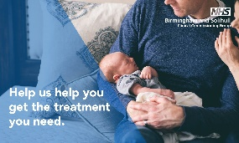
If you need medical help, your local NHS in #Birmingham & #Solihull is still here for you.  If you think you or a family member are suffering with the symptoms of a heart attack you must dial 999 immediately.  Learn more at: https://www.nhs.uk/conditions/heart-attack | 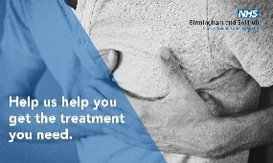
#COVID19 has changed the way you access GP practices in #Birmingham & #Solihull, but your GP is still here to help. Please:  ✔️ Call your GP practice to receive a telephone or video appointment  ❌ Do NOT go to your GP practice in person  Find your GP: https://bit.ly/2YijANM | Use video entitled ‘Accessing GP services’
If you are pregnant, your local NHS in #Birmingham & #Solihull is still here for you.  It is important that you still attend your antenatal appointments and continue to seek advice from your midwife or maternity team.  Learn more at: https://bit.ly/2ShVe2Y | 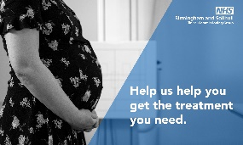
#COVID19 has changed the way you access GP practices in #Birmingham and #Solihull. If you need medical help, please:  ✔️ Call your GP practice to receive a telephone or video appointment  ❌ Do NOT go to your GP practice in person  Find your GP practice: https://bit.ly/2YijANM | Use video entitled ‘Accessing GP services’
Are you the parent of a baby or young child in #Birmingham or #Solihull?

If you are worried about their health, please call 111. If it’s a serious or life-threatening emergency, call 999
Learn more at: https://bit.ly/2ShVe2Y
If you need medical help, your local NHS in #Birmingham & #Solihull is still here for you.  If you think you or a family member are suffering from a stroke, dial 999 immediately. You can spot the symptoms of a stroke by using the FAST test.  Learn more: https://www.nhs.uk/conditions/stroke | 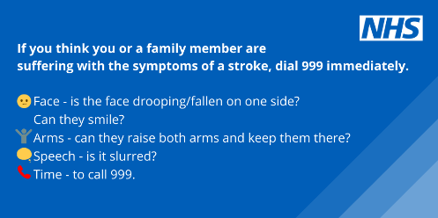
Your local NHS in #Birmingham & #Solihull is here to support your #mentalhealth & #wellbeing during the #coronavirus pandemic.  Learn more about the local support that's available by visiting: https://bit.ly/2KO0UgO | 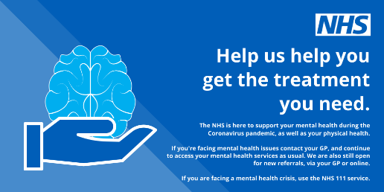

Facebook | Image
If you have a baby or young child, your local NHS in #Birmingham and #Solihull is still here for you.

It is important that they still have their routine vaccinations to protect them against serious and potentially deadly illnesses and stop outbreaks in the community.

Learn more at: https://bit.ly/2ShVe2Y

If you need medical help, your local NHS in #Birmingham & #Solihull is still here for you.

If you think you or a family member are suffering with the symptoms of a heart attack you must dial 999 immediately.

Symptoms include:

▶️ Chest pain
▶️ Pain in other parts of the body
▶️ Feeling lightheaded or dizzy
▶️ Sweating
▶️ Shortness of breath
▶️ Feeling sick (nausea) or being sick (vomiting)
▶️ An overwhelming sense of anxiety
▶️ Coughing or wheezing

Learn more at: https://www.nhs.uk/conditions/heart-attack/symptoms/
If you need medical help, your local NHS in #Birmingham & #Solihull is still here for you.  If you think you or a family member are suffering with the symptoms of a stroke you must dial 999 immediately.  The main stroke symptoms can be remembered with the word FAST:  👉 Face  👉 Arms  👉 Speech  👉 Time  Learn more at: https://www.nhs.uk/conditions/stroke/ | 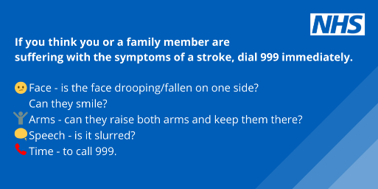
#Coronavirus has changed the way you access GP practices in #Birmingham and #Solihull, but if you need medical help, your GP is still here for you. Please:  ✔️ Call your GP practice to receive a telephone or video appointment  ❌ Do NOT go to your GP practice in person  Find your GP practice: https://bit.ly/2YijANM | Use video entitled ‘Accessing GP services’
If you are pregnant, your local NHS in #Birmingham & #Solihull is still here for you.
It is important that you still attend your antenatal appointments and continue to seek advice from your midwife or maternity team.
Learn more at: https://bit.ly/2ShVe2Y

#COVID19 has changed the way you access GP practices in #Birmingham and #Solihull. If you need medical help, please:  ✔️ Call your GP practice to receive a telephone or video appointment  ❌ Do NOT go to your GP practice in person  Find your GP practice: https://bit.ly/2YijANM | Use video entitled ‘Accessing GP services’
Are you the parent of a baby or young child in #Birmingham or #Solihull?

If you are worried about their health, please call 111. If it’s a serious or life-threatening emergency, call 999
Learn more at: https://bit.ly/2ShVe2Y
Your local NHS in #Birmingham & #Solihull is here to support your #mentalhealth & #wellbeing during the #coronavirus pandemic.
Learn more about the local support that's available by visiting: https://bit.ly/2KO0UgO

Instagram | Image
#COVID19 has changed the way you access GP practices in #Birmingham and #Solihull. If you need medical help, please:  ✔️ Call your GP practice to receive a telephone or video appointment  ❌ Do NOT go to your GP practice in person | Use video entitled ‘Accessing GP services - square’
#Coronavirus has changed the way you access GP practices in #Birmingham and #Solihull, but if you need medical help, your GP is still here for you. Please:  ✔️ Call your GP practice to receive a telephone or video appointment  ❌ Do NOT go to your GP practice in person | 